EDI Web API

Web API 2

Web API Documentation 2

Web API Base URL 2

Authentication 2

Credentials 2

EDI Requests 2

Post Methods 2

Milestone Update [214] 3

Load Tender Response [990] 6

Invoice [210] 7

Get Methods 9

(Single) Load Tender [204] 9

(List) Load Tender**s** [204] 9

JSON Response Example After a Successful Post Request 12

Additional Remarks 13

Web API 13

EDI 13

Recommended Applications 14

Postman 14

Example Usage 14

Telerik Fiddler 14

json2csharp 14

# Web API

Coupled with ***JSON***, this Web API is an ASP.NET CORE HTTP hosting service written in c#.

Its purpose is to facilitate the transfer/exchange of EDI related information (e.g. 204, 214, 210, etc.)

It’s designed to act as a listener, waiting for requests from the client. Data will never be pushed to the client; only returned.

# Web API Documentation

## Web API Base URL

[https://anc-edi.com:5000/](https://anc-edi.com:5000/edi)

## Authentication

Basic Authentication

Base64-encoded string containing user name and password

## Credentials

Two sets of credentials will be given:

1. Test: Provided for sandbox/testing
2. Production: Provided prior to go-live

## EDI Requests

### Post Methods

#### Milestone Update [214]

URL: <https://anc-edi.com:5000/MilestoneUpdates>

***Expected*** updates per each load: Arrive, loaded, empty, check calls, ETA to Delivery. See MilestoneEvent enum in provided code source.

##### Payload Example:

[

{

"TransactionGuid": "884beca8-cfff-42be-adee-9e7ee2eba8d0",

"EDIPartner":

{

"name" : "Sears",

"Id" : 111111

},

"OrderNumber": "12345",

"PartnerOrderNumber": "A12345",

"StopNumber": 1,

"BrokeredShipment":

{

"BrokerSCACCode": "GPSX",

"BrokerTruckNumber": "Truck123"

},

"ReferenceNumbers":

[

{

"Type" : "BookingNumber",

"Value" : "123BN321"

}

],

"Stops":[

{

"StopEntity" :

{

"Type" : "Pickup",

"Name" : "Sears Pick-up Warehouse",

"Location":

{

"AddressLine1" : "123Addr1",

"State" : "MI",

"Lat" : 45.232349

}

}

},

{

"StopEntity" :

{

"Type" : "Delivery",

"Name" : "Sears Delivery Warehouse",

"Location":

{

"AddressLine1" : "123Addr1",

"State" : "MI"

}

}

}

],

"MilestoneDateTime" : "2018-01-10T00:00:00Z",

"MilestoneTotalParts" :

{

"Quantity" : 1,

"Weight" : "20.5",

"WeightQualifier" : "Gross",

"WeightUnitCode": "Pounds",

"BOL" : "bol2",

"POD" : "pod"

},

"MilestoneEvent" : "ArrivedAtPickupLocation",

"MilestoneLocation" :

{

[

{

"TransactionGuid": "884beca8-cfff-42be-adee-9e7ee2eba8d0",

"EDIPartner":

{

"name" : "Sears",

"Id" : 579

},

"OrderNumber": "12345",

"PartnerOrderNumber": "A12345",

"StopNumber": 1,

"BrokeredShipment":

{

"BrokerSCACCode": "GPSX",

"BrokerTruckNumber": "Truck123"

},

"ReferenceNumbers":

[

{

"Type" : "BookingNumber",

"Value" : "123BN321"

}

],

"Stops":[

{

"StopEntity" :

{

"Type" : "Pickup",

"Name" : "Sears Pick-up Warehouse",

"Location":

{

"AddressLine1" : "123Addr1",

"State" : "MI",

"City" : "Ann arbor",

"Zip" : 48109,

"CountryCode": "US",

"Lat" : 42.3032191,

"Lng" : -83.6802387

}

}

},

{

"StopEntity" :

{

"Type" : "Delivery",

"Name" : "Sears Delivery Warehouse",

"Location":

{

"AddressLine1" : "123Addr1",

"State" : "MI",

"City" : "Detroit",

"Zip" : 48202,

"CountryCode": "US",

"Lat" : 42.3751564,

"Lng" : -83.0948781

}

}

}

],

"MilestoneDateTime" : "2018-01-10T00:00:00Z",

"MilestoneTotalParts" :

{

"Quantity" : 1,

"Weight" : "20.5",

"WeightQualifier" : "Gross",

"WeightUnitCode": "Pounds",

"BOL" : "bol2",

"POD" : "pod"

},

"MilestoneEvent" : "ArrivedAtPickupLocation",

"MilestoneLocation" :

{

"AddressLine1" : "123Addr1",

"State" : "MI",

"Lat" : 45.232349

}

}

]

#### Load Tender Response [990]

URL: [https://anc-edi.com:5000/LoadTenderResponse](https://anc-api:5000/edi/LoadTenderResponse)s

##### Payload Example:

[

{

"TransactionGuid": "6787b328-4a3a-4b52-a8de-b4aadc470f40",

"EDIPartner": {

"name" : "Sears",

"Id" : 579

},

"OrderNumber": "12345",

"PartnerOrderNumber": "A12345",

"ReservationStatus":{

"status": "Accepted"

}

},

{

"TransactionGuid": "a549660d-7cb2-410a-b5fb-49206b50d703",

"EDIPartner": {

"name" : "K-Mart",

"Id" : 22222

},

"OrderNumber": "12346",

"PartnerOrderNumber": "A12346",

"ReservationStatus":{

"status": "Declined"

}

}

]

#### Invoice [210]

URL: <https://anc-edi.com:5000/Invoices>

##### Payload Example:

[

{

"TransactionGuid": "884beca8-cfff-42be-adee-9e7ee2eba8d0",

"EDIPartner":

{

"name" : "Sears",

"Id" : 579

},

"OrderNumber": "12345",

"PartnerOrderNumber": "A12345",

"InvoiceNumber": "123450A",

"InvoiceDate": "2018-01-25T00:00:00Z",

"FirstPickupDate": "2018-01-25T00:00:00Z",

"LastDeliveryDate": "2018-01-25T00:00:00Z",

"ReferenceNumbers":

[

{

"Type" : "BookingNumber",

"Value" : "123BN321"

}

],

"BuisnessEntities":[

{

"Type" : "BillTo",

"Name" : "Sears Headquaters",

"Location": {

"AddressLine1" : "123Addr1",

"State" : "MI",

"City" : "Romulus",

"Zip" : 48174,

"CountryCode": "US",

"Lat" : 42.2030778,

"Lng" : -83.4167955

}

}

],

"LineItems":[

{

"Description" : "Linehaul by Mileage",

"Rate" : 675.11,

"Quantity" : 1,

"LineCharge":"675.11",

"ChargeDescriptionType": "Linehaul",

"RateUnitOfMeasureType": "Flat"

},

{

"Description" : "Fuel Surcharge %",

"Rate" : 0.19,

"Quantity" : 657.32,

"LineCharge":"124.89",

"ChargeDescriptionType": "Fuel",

"RateUnitOfMeasureType": "Percent"

}

],

"Currency" : "USD",

"Stops":[

{

"StopEntity" :

{

"Type" : "Pickup",

"Name" : "Sears Pick-up Warehouse",

"Location":

{

"AddressLine1" : "123Addr1",

"State" : "MI",

"City" : "Ann arbor",

"Zip" : 48109,

"CountryCode": "US",

"Lat" : 42.3032191,

"Lng" : -83.6802387

}

}

},

{

"StopEntity" :

{

"Type" : "Delivery",

"Name" : "Sears Delivery Warehouse",

"Location":

{

"AddressLine1" : "123Addr1",

"State" : "MI",

"City" : "Detroit",

"Zip" : 48202,

"CountryCode": "US",

"Lat" : 42.3751564,

"Lng" : -83.0948781

}

}

}

],

"TotalParts" :

{

"Quantity" : 1,

"Weight" : "20.5",

"WeightQualifier" : "Gross",

"WeightUnitCode": "Pounds"

}

}

]

### Get Methods

#### (Single) Load Tender [204]

URL: [https://anc-edi.com:5000/LoadTender/{TransactionGuid}](https://anc-edi.com:5000/LoadTender/%7bTransactionGuid%7d)

*See sample Json body in next section.*

#### (List) Load Tender**s** [204]

URL: [https://anc-edi.com:5000/LoadTenders](https://anc-api:5000/edi/LoadTenders)

[

{

"TransactionGuid": "59fbc481-dfa9-452f-b9c0-46d94f47abcd",

"EDIPartner": {

"name" : "Sears",

"Id" : 111111

},

"OrderNumber": "12345",

"PartnerOrderNumber": "A12345",

"MethodOfPayment": "Prepaid",

"LoadTenderStatus": "Original",

"MustRespondByDateTime": "2018-01-25T00:00:00Z",

"ReferenceNumbers":[

{

"Type" : "BookingNumber",

"Value" : "123BN321"

}

],

"Instructions":[

{

"Type" : "Alert",

"Value" : "123BN321"

}

],

"BuisnessEntities":[

{

"Type" : "BillTo",

"Name" : "Sears Headquaters",

"Location": {

"AddressLine1" : "123Addr1",

"State" : "MI",

"City" : "Detroit",

"Zip" : 48202,

"CountryCode": "US",

"Lat" : 42.3751564,

"Lng" : -83.0948781

}

},

{

"Type" : "RemitToParty",

"Name" : "Sears C/O CASS",

"Location": {

"AddressLine1" : "123Addr1",

"State" : "MI",

"City" : "Ann arbor",

"Zip" : 48109,

"CountryCode": "US",

"Lat" : 42.3032191,

"Lng" : -83.6802387

}

}

],

"Stops":[

{

"StopNumber": 1,

"ReferenceNumbers":[

{

"Type" : "BookingNumber",

"Value" : "123BN321"

}

],

"Instructions":[

{

"Type" : "Alert",

"Value" : "123BN321"

}

],

"Parts":[

{

"Weight" : "20.5",

"Quantity" : "8",

"WeightQualifier" : "Gross",

"WeightUnitCode": "Pounds",

"BOL": "BOL123"

}

],

"DateTimes":[

{

"TimeQualifier" : "Earliest",

"Value" : "2018-01-25T00:00:00Z",

"TimeZone" : "EasternTime"

},

{

"TimeQualifier" : "Latest",

"Value" : "2018-01-25T00:00:00Z",

"TimeZone" : "EasternTime"

}

],

"StopEntity" : {

"Type" : "Pickup",

"Name" : "Sears Pick-up Warehouse",

"Location": {

"AddressLine1" : "123Addr1",

"State" : "MI",

"City" : "Ann arbor",

"Zip" : 48109,

"CountryCode": "US",

"Lat" : 42.3032191,

"Lng" : -83.6802387

}

}

},

{

"StopNumber": 2,

"ReferenceNumbers":[

{

"Type" : "BookingNumber",

"Value" : "123BN555"

}

],

"Instructions":[

{

"Type" : "Alert",

"Value" : "123BN555"

}

],

"Parts":[

{

"Weight" : "20.5",

"Quantity" : "8",

"WeightQualifier" : "Gross",

"WeightUnitCode": "Pounds"

}

],

"DateTimes":[

{

"TimeQualifier" : "Scheduled",

"Value" : "2018-01-28T00:00:00Z",

"TimeZone" : "EasternTime"

}

],

"StopEntity" : {

"Type" : "Delivery",

"Name" : "Sears Delivery Warehouse",

"Location": {

"AddressLine1" : "123Addr1",

"State" : "MI",

"City" : "Detroit",

"Zip" : 48202,

"CountryCode": "US",

"Lat" : 42.3751564,

"Lng" : -83.0948781

}

}

}

],

"TotalParts" : {

"Quantity" : 1,

"WeightQualifier" : "Gross",

"BOL" : "bol2",

"POD" : "pod"

}

}

]

# JSON Response Example After a Successful Post Request

##### Below is an example of 2 of the transactions failing out of the 3. This can happen for any post type request.

{

"resultStatus": {

"errors": [

{

"message": "PICKUP FAILED FOR TRADING PARTNER 11111 DUE TO...",

"transactionGuid": "2a50ee5c-daa2-42f9-b2a3-35fd4213dced"

},

{

"message": "DELIVERY FAILED FOR TRADING PARTNER 11111 DUE TO...",

"transactionGuid": "7a1cc464-8866-4acf-8853-e73695479ef2"

}

],

"success": [

{

"transactionGuid": "f4b9f4ed-c050-47a9-9d38-d6cae705cce7"

}

]

}

}

# Additional Remarks

## Web API

* All DateTime datatypes are to be processed as UTC, unless datatype is of DateTimeSpecial. In the EDI world, the trading partner may send or request local time. For this, we have no accurate way of determining the exact time. So, in cases like this, we’ll just return it to you as they provide it (in LT).
* Each request and response will and must contain a GUID. The guid is provided in the TransactionGuid property of the json request/response.
* When posting, if some transactions fail due to validation rules, it’ll still return a 200 HTTP OK status with the body containing the error message in json format
* A 500 HTTP server status error will just return a single line of text and not JSON

## EDI

* All Load Tenders (204) require a Load Tender Response (990)
* When sending a stop within the milestone (214) update, only the StopEntity (location, etc.) needs to be provided and NOT the full stop details
* Invoices (210) will not support rebills/credits; only the originals
* Milestone updates (214): Arrive, loaded, empty, check-calls, and *ETAs to final delivery* are expected for all active loads being tracked via this integration. Check calls are expected every hour
* Logs will be kept for 6 months

# Recommended Applications

## Postman

A free GUI that aids in the testing of http(s) web requests

<https://www.getpostman.com/>

### Example Usage

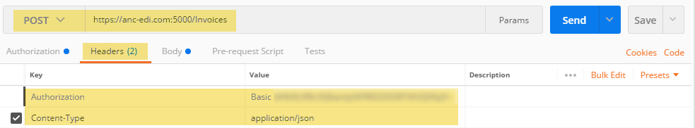

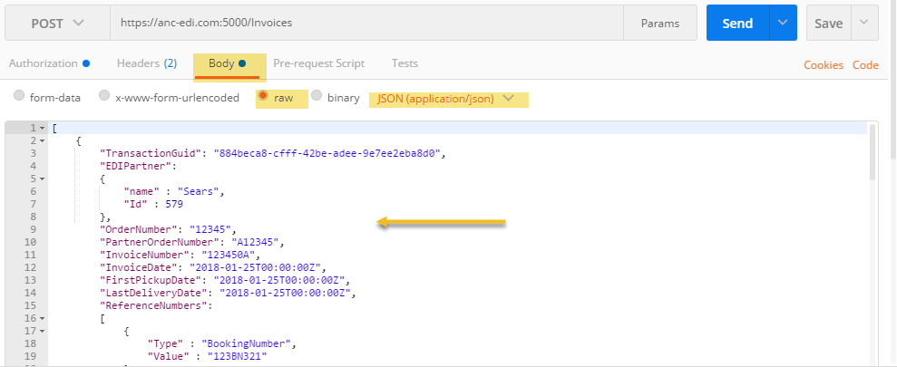

## Telerik Fiddler

A free GUI that allows you to decipher/log/debug http(s) requests and responses

<https://www.telerik.com/download/fiddler-wizard>

## json2csharp

A tool that converts JSON to C# classes

<http://json2csharp.com/>